Fuel Tax Quarterly Reports are to be reported by the end of the following month, except for Kentucky, New Mexico, New York and Oregon, after the completion of each calendar year quarter, as follows:

QUARTER | REPORT DUE DATE | 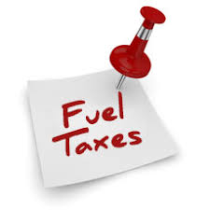
First – January 1 – March 31 | April 30 | ☆☆☆☆☆
Second – April 1 – June 30 | July 31 | ☆☆☆☆☆
Third – July 1 – September 30 | October 31 | ☆☆☆☆☆
Fourth – October 1 – December 31 | January 31

